Collections

PART1:(1 to2)

Collections is a kind of framework given number of API which store and manipulate the data or object.

Note: Collections is concept and Collection is an interface in Java

In the attached picture rectangle indicates interface and circle indicates class.

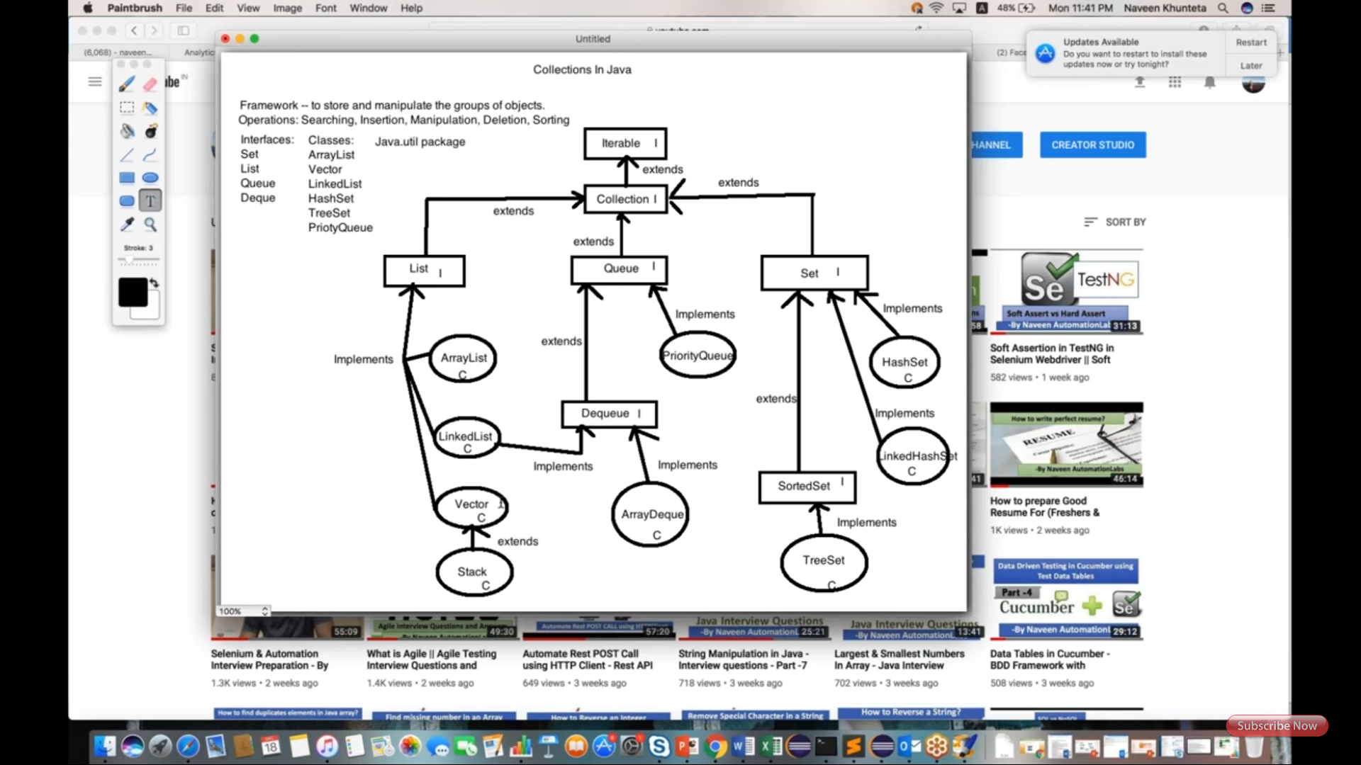

PART2: (Page:2 to 10)

Arraylist used and stored objects in it, attached 1st screenshot.

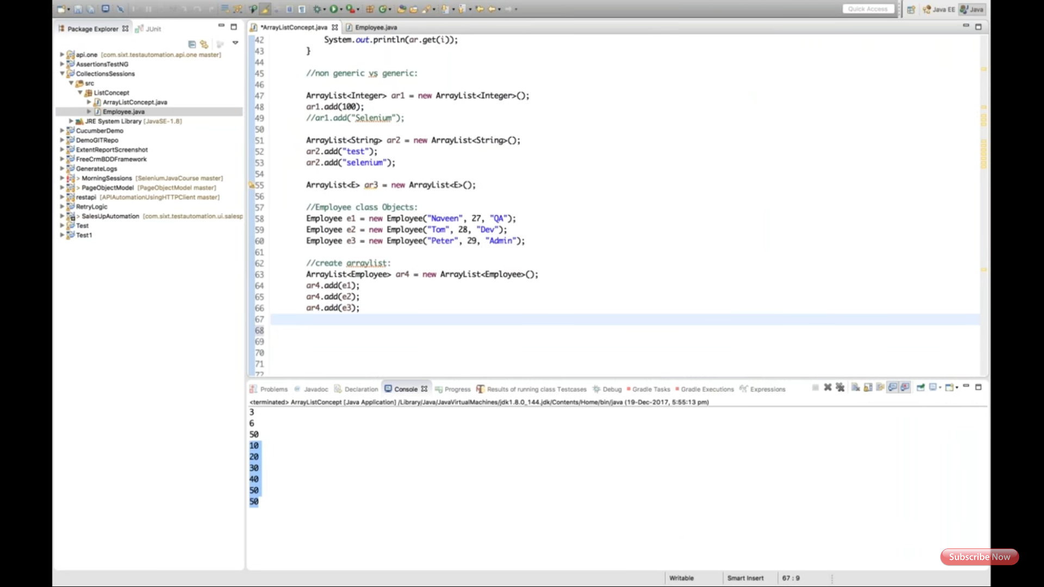

Iterator used to transform values and printed, attached 2nd screenshot.

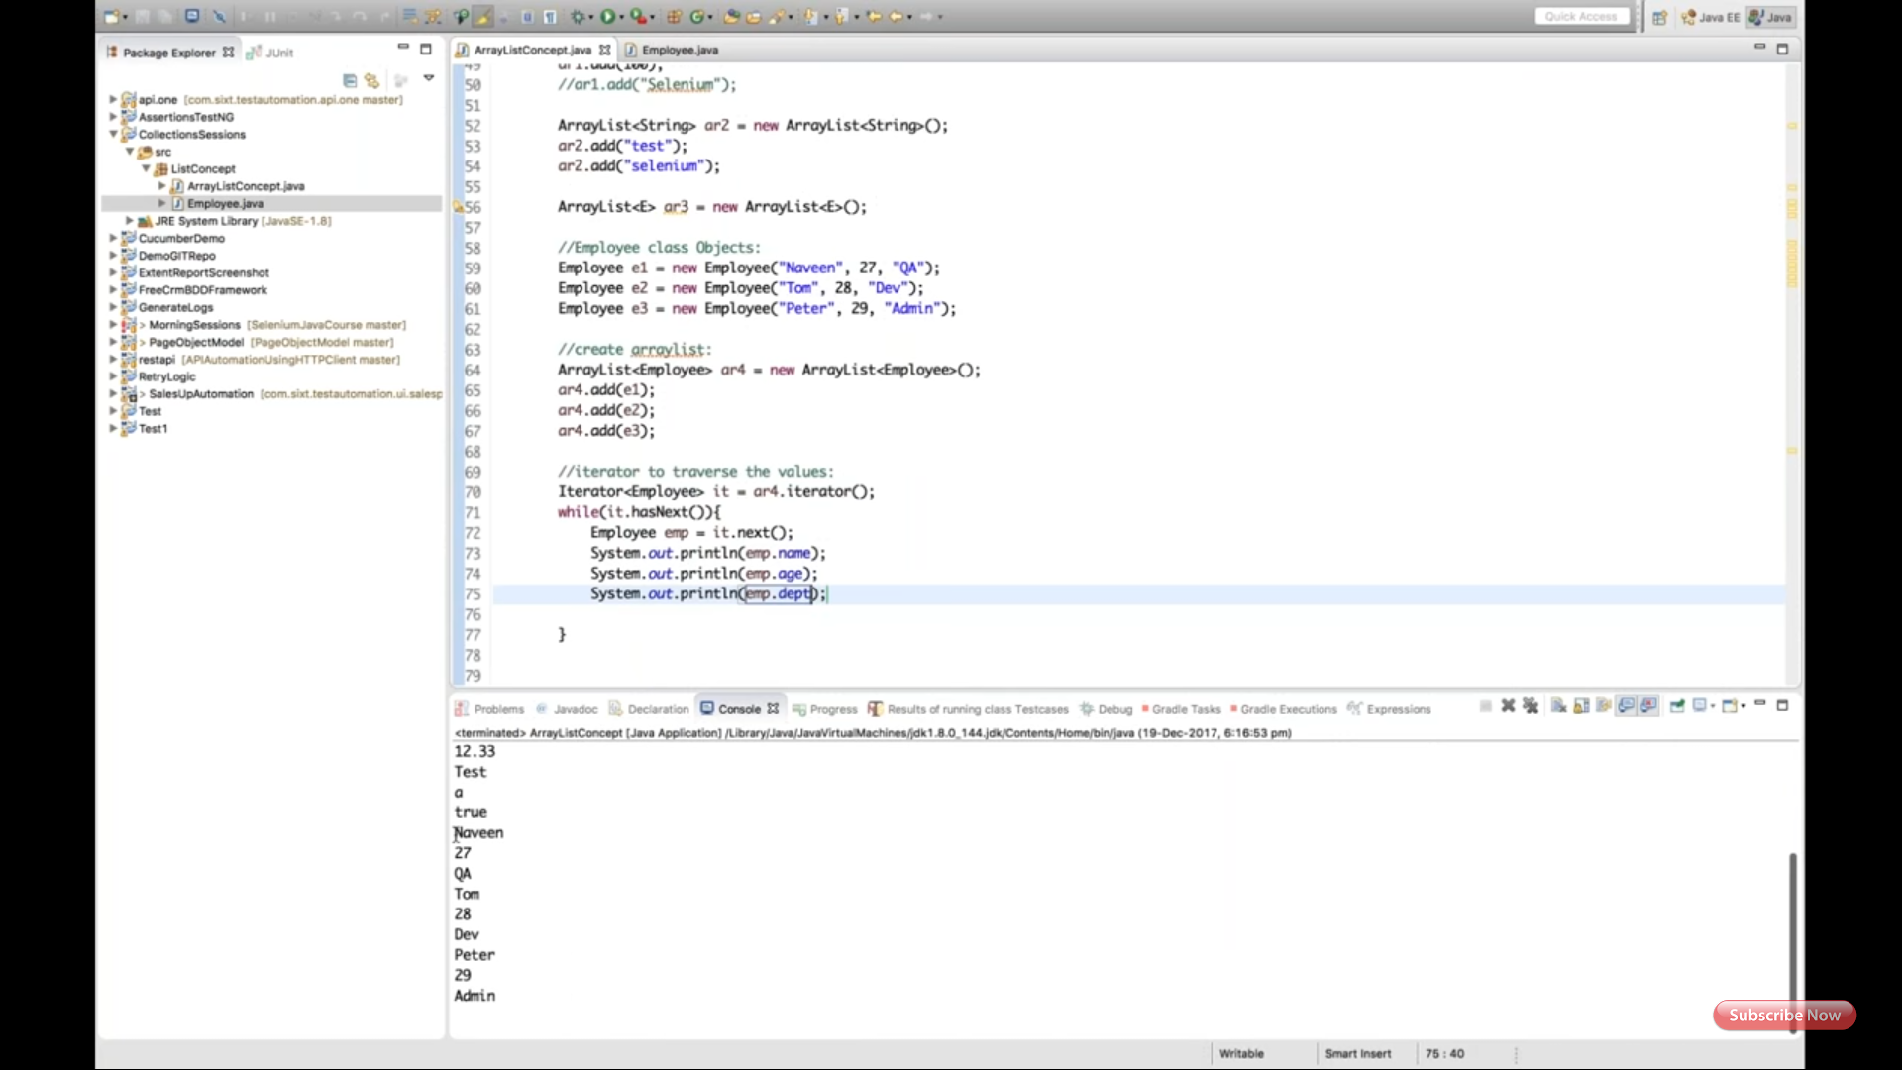

Arraylist addAll() and removeAll() explained how it merge obj1 and obj2, attached 3rd screenshot.

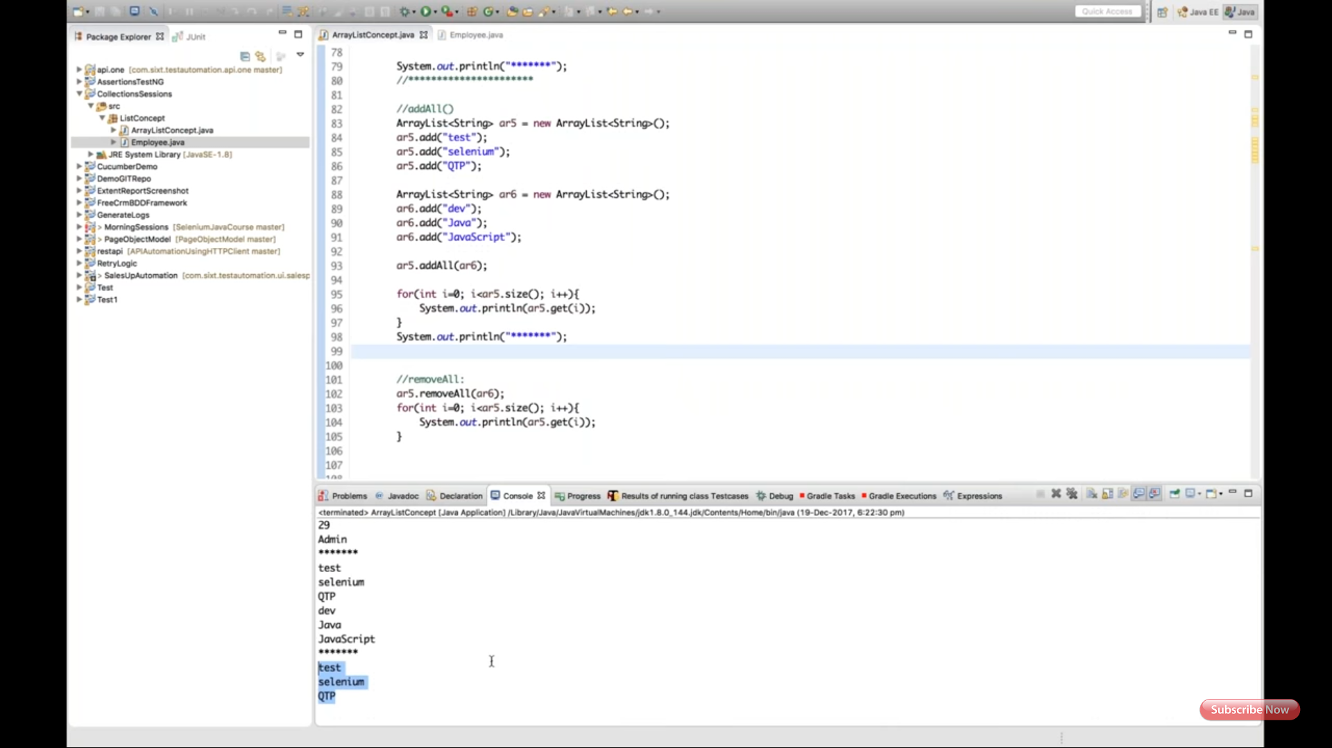

Arraylist retainAll() explained how it retains only common values in two different objects, attached 4th screenshot.

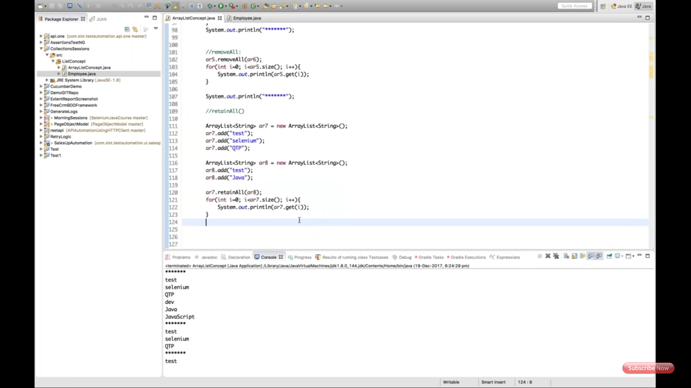

PART 3: (6 to 10)

LinkedList... Singly LinkedList diagram explained, attached 1st screenshot.

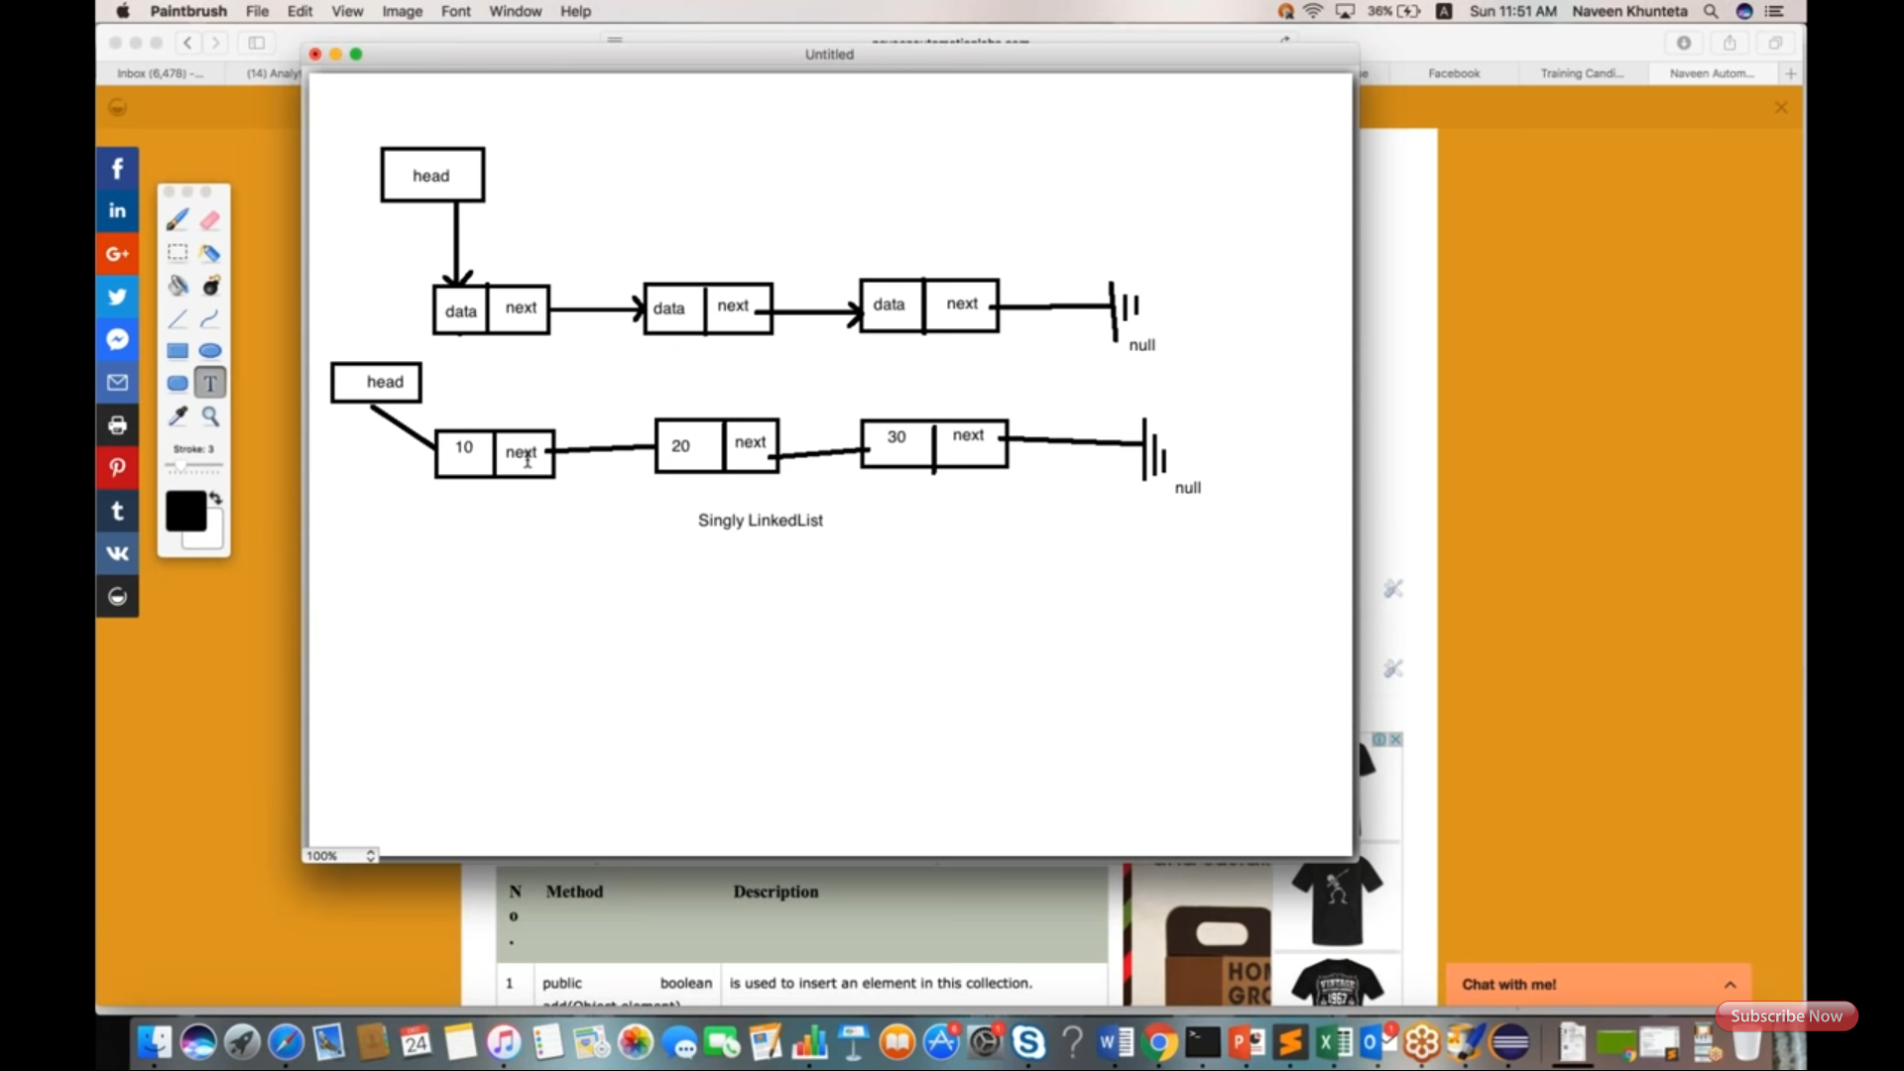

LinkedList declaration, add and print explained, attached 2nd screenshot.

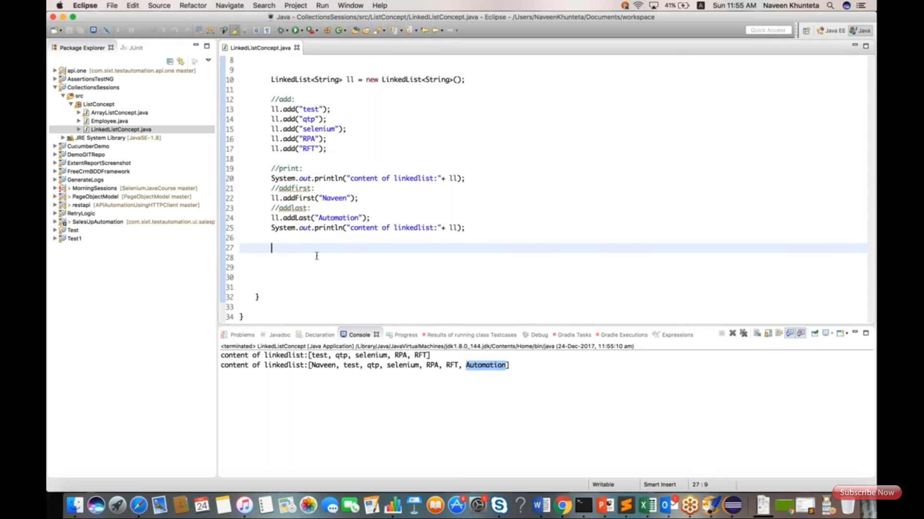

LinkedList get, set and remove explained, attached 3rd screenshot.

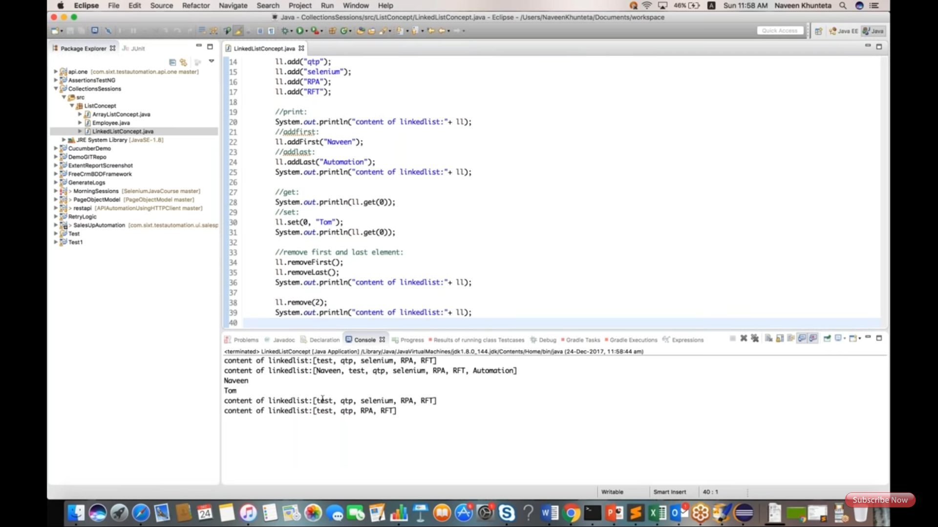

LinkedList printing by using for and advance for loop, attached 4th screenshot.

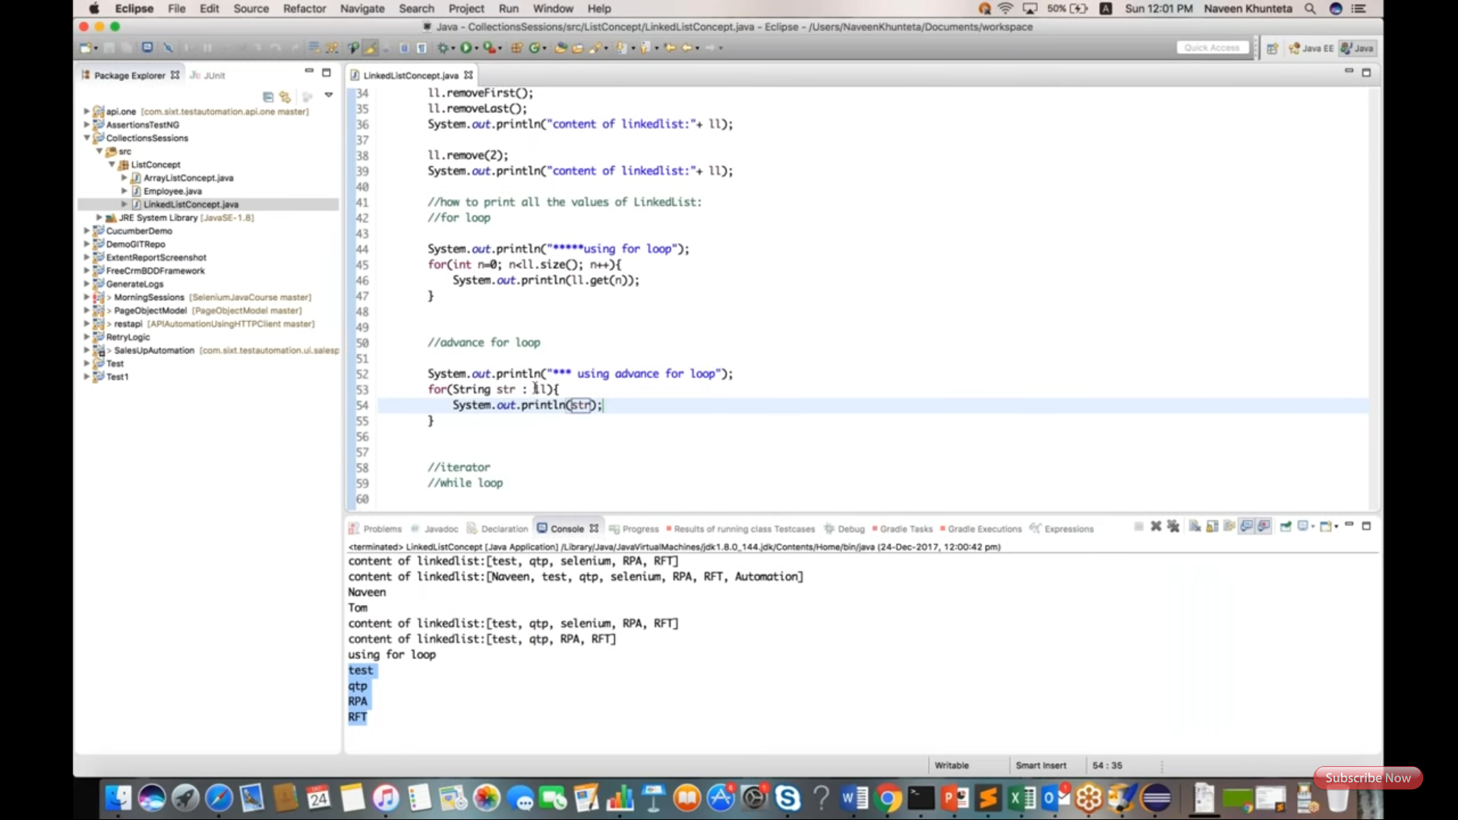

LinkedList printing by using iterator and while loops, attached 5th screenshot.

